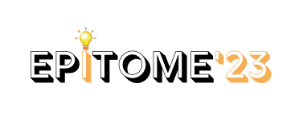

**WORK STRUCTURE FOR EPITOME’23**

**ADMIN WORK**

1. Conduction of Event letter
2. Room permission
3. Publicity Permission
4. Gate Pass
5. Allow of other college students
6. Halls permission to conduct the event HALL-1,2 CSE, ECE-SEMINAR
7. Non-Tech events permission
8. College promotions permission i.e Announcements, Helpdesks
9. Banners- ECE BLOCK, MAIN GATE
10. Artwork permissions
11. Core team Attendance from all theHODs
12. Faculty coordinators
13. Internet connection
14. Power Supply
15. Extension Boxes For 3 Halls
16. Maintenance
17. Banners & posters permission

**DOCUMENTATION**

Every Letter Needed To Conduct the Event should be drafted by the DOC team If anything needs to be documented DOC team has to Take care

**GRAPHIC DESIGN**

1. Poster Design
2. Videos Release
3. Instagram promotion designs
4. ID cards
5. Tags
6. T-shirt Designs
7. ECE -50ft Design
8. Gate Banner designs
9. HALL designs
10. Photo booth design
11. Stickers of Epitome